Port Forwarding (External Access)

- Login to your router via the default gateway address. (An easy way to find out your default gateway is to open up the start menu, opening the command prompt and typing the following command: ipconfig)

See the picture below.

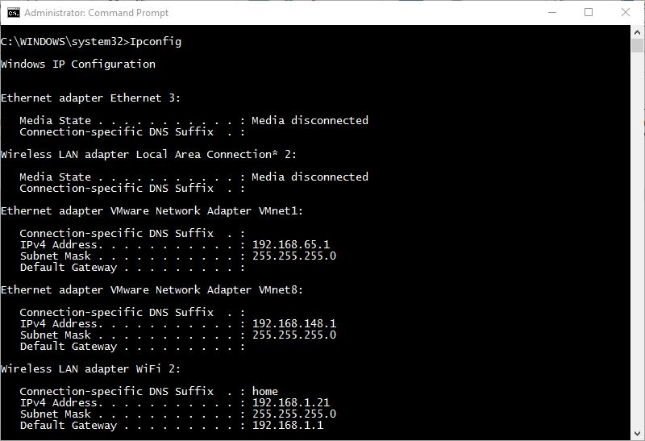

- Your default gateway might be different, so don’t just type in the gateway listed above. After typing in the default gateway into your browser, it should send you to your router’s option page. It might look something similar to the picture below, differing on your internet service provider and your make of router.

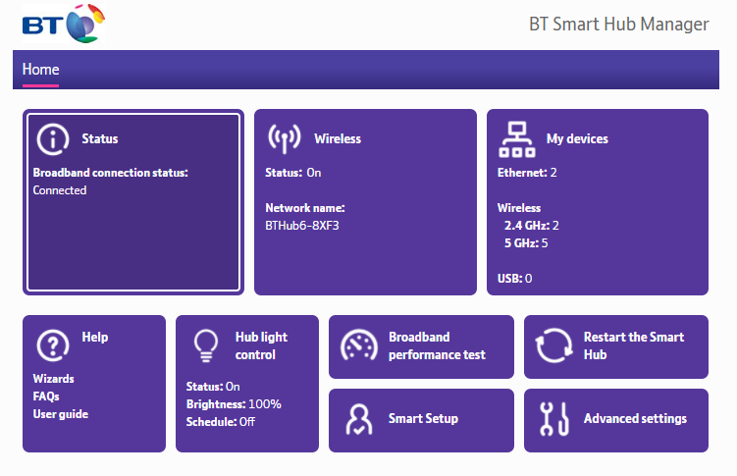
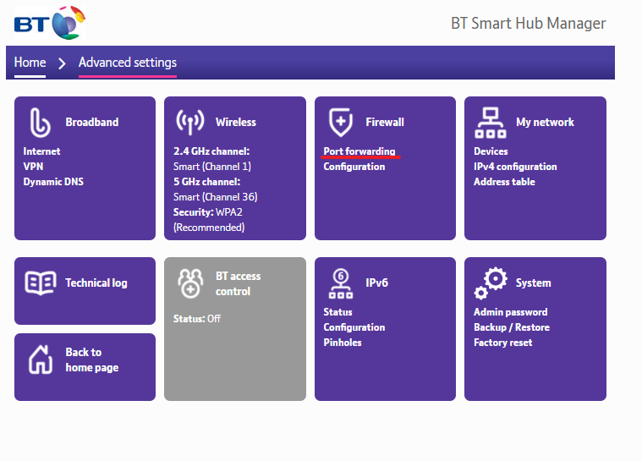

- Find the Port Forwarding section. It might be hidden behind Advanced Settings, or Firewall options.

- In the Port Forwarding page enter in a name for your device. Then enter the port you are forwarding in the port field (the port for the DVR can be found and changed in the NETWORK -> UPnP section. Ensure that PAT is enabled!). Select “TCP/UDP” and enter the internal IP address of the device you are port forwarding to and click “Apply” or “Save” to store the changes.

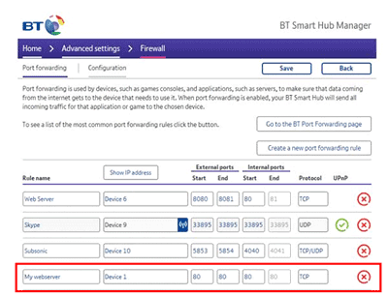

- Now that you’ve successfully port-forwarded, you should be able to access the web menu from outside your home network. Typing in your external IP address, which you can find by googling “What is My Public IP” and finding a website such as www.whatismypublicip.com or www.whatismyip.com and finding your public IPv4.

Type your external IP into the Internet Explorer browser with the addition of a
:”port number”
e.g. 64.71.732.37:80 (if your port was 80). This should load up the web-menu view, even if you’re not connected to the same network as the DVR – Logging in with the same username and password used to set it up.
