
NW765
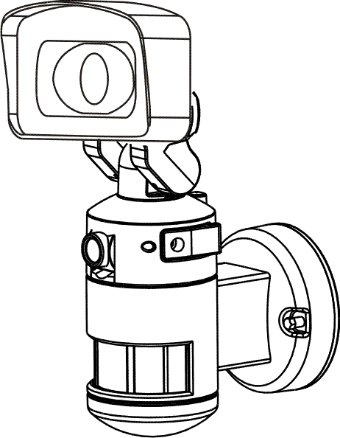
MOTORIZED LED FLOOD LIGHT WITH WIFI CAMERA

Troubleshooting and FAQ V3.1

Important – your account basics
When you set up the NightWatcher with your WiFi and the NightWatcher HD app, it registers the unique camera ID no. with the NightWatcher server. This registration is permanent and remote.

It does not reside on the app, on your phone or WiFi router. Thus, you can access your account from any Android or iOS device through the app with your login. It also means that deleting the app, changing device or losing a phone has no effect on the registration. Each time the app is used, the app signs in with the server as a security protocol to prevent others viewing your camera feed. If the WiFi signal is weak, or if there is another issue with the router (too much traffic, interference from other routers on the same channel, network provider issues etc.) it will struggle to make this initial connection and this can lead to unexpected problems.

The only way to remove a device from your account is to log into the app, go to settings > remove device.

Thus, it is very important that you make a physical record of your account login and password. Losing these details means you lose access to your account and all devices on it.

Login:

Password:

Possible problems with camera installation and the solutions:

Troubleshoot by symptom

- Live view works but no video clips can be seen in history
- Motion detection is not activated in the app settings - See NW765 IM final V3.0 Enabling video (Page 12)
- Micro SD card is corrupt. Reformat or replace if necessary – See NW765 IM final V3.0 formatting your memory card (Page 5)
- No micro SD card is inserted in the NightWatcher

- Live view works but only still images can be seen in history
- Micro SD card is corrupt. Reformat or replace if necessary -See NW765 IM final V3.0 formatting your memory card (Page 5)
- No micro SD card is inserted

- NightWatcher will not complete set up.
- Check wifi signal strength at NightWatcher with a signal checking app. See NW765 IM final V3.0 page 6
- Check physical connection
- Reset NightWatcher and try again
- Delete NightWatcher app, reinstall app and try again

- Error code 128
This means the user has reset their password and been given a temporary password. This temporary password must be replaced with the time limit (30 mins) as directed onscreen.

- Not getting push notifications
- Push notifications disabled in NightWatcher HD – From the Live view screen, go to Settings>Notifications>motion detection push – touch the enable slider
- Check NightWatcher wifi connection
- Check mobile signal
- Check data is enabled on mobile phone (if outside wifi zone).
- Check that push notification has not been disabled on the app preferences in Android on your phone. Settings>apps>NightWatcher HD>show notifications

- Cannot access account
- Login details incorrect – if you used your e-mail check details, if you used a name check spelling and case.
- May indicate a temporary connection issue to the NightWatcher server – check connection to internet or try again later.
- If all else fails, contact NightWatcher at NightWatcher.co.uk/support

- Authentification failure
- Can be wifi or mobile data connection – check signal by other means
- May indicate a temporary connection issue to the NightWatcher server – check connection to internet or try again later.

- Forgotten/incorrect password
On login screen, press the ‘Forget your password?’ button, then enter the email or username used to sign up to the account. After hitting ‘confirm’, an email will be sent to the address used for the account. Follow the instructions to reset your password. (Password resets are only valid for 30 minutes).

Trouble shoot by cause - common problems.

- Insufficient WiFi signal
- Incorrect login process
- Corrupted micro SD card
- Incorrect siting of the device
- Out of date software
- Very old, unsupported operating system

- Download and install a wifi signal checker/analyser to your mobile phone. Check the signal strength at the NightWatcher. If signal is poor move the router closer to the NightWatcher or put a range extended between router and NightWatcher.
- Always write down your login details and keep in a same place (perhaps the NightWatcher box). Do not use special characters (@#~$”& etc.) as these may not be recognised.
- Removing the micro SD card while the camera is recording is the most common cause of corruption. Power failure during a recording can also have the same effect. In some cases the card can be reformatted, have its bad sectors repaired or flagged as damage and the card reused. In other cases, it needs to be replaced. Memory cards are cheap enough to keep spares.
- Re-read the installation instructions and re-site the device if necessary.
- Update the NightWatcher app to latest version
- Change the app host device

WiFi/Router issues;

1. The router may be set to prevent unauthorised access: if the WI-FI network is set to prevent unauthorised access (Black and White List, MAC address filtering " etc.) this may lead to network connection failure.

2. The router may be set 5GHz WIFI: 5GHz Wi-Fi is not currently supported.

3. Bridge-connected WiFi: bridge-connected Wi-Fi may lead to an unstable network which may cause the Wi-Fi
connection to fail.
4. DHCP may not be enabled in order to assign IP addresses automatically: if your router DHCP is disabled this may not allow the camera to obtain a valid IP address and cause the WI-FI connection to fail.

5. Check permissions on your mobile phone app. Check that it is allowed to use data and connect to wifi.

6. The router has a hidden Wi-Fi setting: the NightWatcherHD camera does not support a hidden SSID, please ensure the SSID is not hidden.

Account/ID issues
1.App displays message: "This device has been added to another account"
In order to protect the privacy of our users, NightWatcherHD devices can only be added to one account. It is possible for more than one user to connect to the same account to view devices and receive push alerts.
Live video sharing; you can also click "SHARE" in the settings to enable your family and friends access your live streams

2.How to remove a device from your account?
In the Home screen, select your device from the list, then press and slide to the left and press "Delete".

3.How to move a device from one account to another account?
Firstly, from the current account, in the Home screen, select your device from the list, then press and slide to the left and press "Delete". Then login to the other account and add the device.

4. App displays message “Authentification failure”. Check login details and retry.

5. Forgotten password/ID not recognises: contact NightWatcher via website support.

Video play issues:
1. I can see live view but can’t see history. Check wifi signal at NightWatcher. Reboot app. Check app for updates. Shut down NightWatcher and remove micro SD card to check it is not corrupted.

2. Why can I play it when I'm at home but not outside?
When the camera and the App client are in the same local area network (LAN), you can view the device via the intranet search feature. However, the device cannot be viewed outside the local area network until the device has been added successfully to the User Account.

3. Why does the video play smoothly when I'm at home but not outside? What are the broadband requirements of the camera?
The NightWatcherHD camera real-time play has third modes: HD, SD and Automatic;
(1:) Real-time viewing while in HD mode, Asymmetric Digital Subscriber Loop
(2:) Real-time viewing while in SD mode.
(3:) Real-time viewing while in Automatic mode.

Power and physical issues
1. What if the camera stays off-line; Blue LED is not lit, camera does not move or transmit?
Check power to the device. Check circuit breakers, check fuse in fused spur. Remove NightWatcher from mount and check power at device (Warning – 240V mains power! Expertise and safe operating procedures apply.

2. The camera is hot; is it safe?
The device will operate normally with the range of -10°C to + 55°C. Extended use may cause the device to appear hot but this is totally safe and will not affect operation.

If the camera remains off-line, please power the device off and on and reconfigure the WI-FI connection. If necessary, delete the app and reinstall from start.

3. What type of power lead should I fit to my NightWatcher?
3A, 3-core (twin and earth).

4. What value fuse should I put in the plug?
The fuse should be rated to protect the mains lead. So, assuming you used 3A flex, use a 3A fuse.

Operating systems supported
- Which mobile phone operating system does NightWatcherHD currently support?
The NightWatcherHD App currently supports iOS 8.0 and higher and Android 4.4.0 and higher.

Specification questions
- How does the night vision feature work?
The camera has High power lightning LED, it will be triggered when someone's moving and the light is less than 3 lux within 10 meters.
- How many trigger events can be stored on the SD card?

- What happens when the SD card is full?
When the memory card is full, it will over-write the earliest recordings. Video can also be backed up by removing the SD card from the camera and saving to a PC or MAC

Camera LED code
Blue steady LED – Light connected to WiFi in normal operation
Blue LED flashing 1/sec – Connecting to WiFi
Blue LED flashing rapidly 2/sec – WiFi resetting

Red LED – The red LED may light very briefly in normal operation but if it comes on and stays on, or flashes fro more than a few seconds this indicates a fault. May indicate the micro SD card has been removed or needs to be re-formatted, See NW765 IM final V3.0 pages 3 and 4. Or it may indicate that the NightWatcher needs to be reset.

PIR window LED codes
Red
Orange
Green

See NW765 IM final V3.0 page 3

